Architecture Document: Distributed Real-Time Drawing Board
PES University | Department of Computer Science | Section K
Project: Distributed Real-Time Drawing Board with Mini-RAFT Consensus
Team Members: * Tarun M Gowda (PES1UG23CS639)
- [Teammate 2 Name]
- [Teammate 3 Name]
- [Teammate 4 Name]

1. System Overview
The Distributed Real-Time Drawing Board is a cloud-native, fault-tolerant collaboration application designed to mimic the reliability of production systems like etcd and Kubernetes control planes. The system utilizes a multi-container microservice architecture connected via Docker networks, employing WebSockets for low-latency client communication and a custom Mini-RAFT consensus algorithm for distributed state replication.
2. Cluster Architecture
The infrastructure is composed of two primary layers: a stateless WebSocket Gateway and a stateful cluster of three Replicas.
- The Gateway: Acts as the ingress controller and connection manager. It maintains active WebSocket connections with browser clients, polls the backend cluster to identify the current active Leader, routes all incoming drawing strokes to that Leader, and broadcasts committed state changes back to all connected clients.
- The Replica Cluster: Three isolated Docker containers acting as the distributed database. They communicate internally via HTTP RPCs to maintain a synchronized, append-only log of drawing strokes

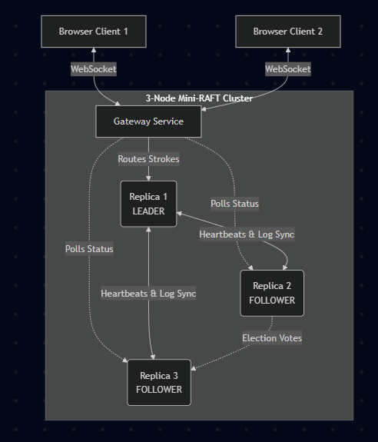
3. Mini-RAFT Protocol Design
The consensus layer is an implementation of the RAFT algorithm optimized for real-time event streaming.
3.1 Term & State Management
Time is divided into logical "Terms" representing periods of leadership. Each replica operates strictly in one of three states: Follower, Candidate, or Leader.
- Followers are passive, responding to RPCs from Candidates and Leaders.
- Candidates actively request votes to transition to Leadership.
- The Leader handles all client log appends and synchronizes the cluster.
3.2 Leader Election Mechanics
Elections are driven by randomized timeouts to prevent split votes.
- If a Follower receives no /append-entries heartbeat within a randomized 500-800ms window, it assumes the Leader is dead.
- It increments its current term, transitions to Candidate, votes for itself, and broadcasts a /request-vote RPC.
- If it receives an affirmative response from a majority of the cluster (≥2 votes), it assumes the Leader state and immediately begins broadcasting heartbeats every 150ms to suppress further elections.
3.3 Log Replication Pipeline
When a user draws a stroke, the following sequence ensures ordered replication:
- The Gateway forwards the stroke payload to the active Leader.
- The Leader appends the stroke to its local, append-only log.
- The Leader packages the stroke into an /append-entries RPC and broadcasts it to all Followers.
- Upon successful replication across the quorum, the Gateway broadcasts the stroke to all WebSocket clients for rendering.
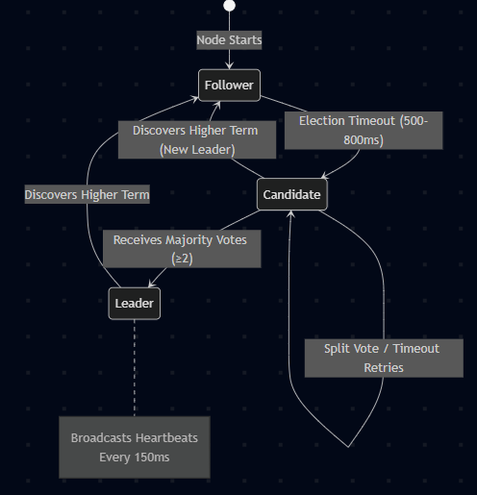
5. Internal API Definition (RPC Endpoints)
The cluster utilizes HTTP REST for internal RPCs. All payloads are strict JSON dictionaries.
- POST /request-vote
  - Function: Used by Candidates to solicit votes during elections.
  - Payload: { term: int, candidate_id: int, last_log_index: int }
  - Response: { term: int, vote_granted: bool } - Grants vote if the candidate's term is $\ge$ the receiver's term and log is up to date.
- POST /append-entries (Heartbeats & Logs)
  - Function: Used by Leaders to replicate logs and suppress elections. Sent every 150ms.
  - Payload: { term: int, leader_id: int, prev_log_index: int, entries: list }
  - Response: { term: int, success: bool, log_length: int } - Returns success: false if terms clash or if the follower is missing previous log entries.
- POST /sync-log
  - Function: The Catch-Up protocol endpoint. Invoked dynamically by the Leader when an /append-entries response indicates a Follower has a smaller log length.
  - Payload: { entries: list } - Contains the specific sub-array of missing drawing strokes.
6. Failure-Handling & Zero-Downtime Design
The system guarantees zero-downtime operation and eventually consistent state across the following failure domains:
6.1 Leader Failover
If the active container hosting the Leader fails, the 150ms heartbeat ceases. Within a maximum of 800ms, the surviving nodes will trigger an election. Because the cluster size is 3, the 2 surviving nodes form a valid quorum, successfully electing a new leader without manual intervention. The Gateway autonomously detects this topology change and re-routes new strokes, preventing client disconnection.
6.2 Rolling Upgrades (Blue-Green Replacements)
Source code is mounted into the containers via Docker volumes. When a file is modified, Uvicorn triggers a graceful hot-reload.
- If a Follower reloads, it simply misses a few heartbeats and resyncs upon waking.
- If the Leader reloads, an automatic failover occurs in the $\sim$1 second the container takes to restart.
6.3 The Catch-Up Protocol (Node Recovery)
When a restarted node rejoins the network, its internal log array is empty. Upon receiving the first heartbeat from the active Leader, the node compares prev_log_index and replies with success: false along with its current log_length. The Leader calculates the precise delta of missing strokes and transmits them via /sync-log, ensuring the node achieves parity before participating in standard replication.

